

Examiners’ Evaluation Form

Examinaer’s Name: Khan Raqib Mahmud, Lecturer, CSE, ULAB

 |  | Marks
St ID | St Name | Amount of Work done  (30) | Methodology  (10) | Analytical &Creativity  (20) | Presentation  (20) | Question & Answer  (20) | Total  (100) | Comments
182014057 | Mahdia Amena | 23 | 7 | 13 | 18 | 15 | 76
162014014 | Atia jahan | 20 | 7 | 14 | 15 | 14 | 70
161014027 | Meanhazul Abedin Turase | 20 | 7 | 12 | 17 | 14 | 70

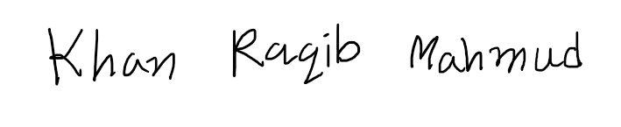

13.10.2020

Examiner’s signature with date

